Functional options
When developing an applied solution, especially if it is a mass-produced solution that is developed not for the needs of one specific company, but for the various needs of companies in a certain segment (production, trade, accounting...), it often happens that it is necessary to provide for the enabling and disabling some functionality, for example, in one database with the “Trade management” configuration, accounting for several currencies is turned on, but in another database it is not. One database maintains accounting records, but the other does not.
Such a type of division is also possible within one database by individual areas (for example, by organizations). Imagine that there is a group of several companies; the economic activities of this group of companies are recorded in one information base. At the same time, one of the companies requires accounting in the context of contracts with partners in the same program, while the other company does not need such accounting, but some other additional analytics is needed that is not needed by the first company. If you simply enable the functionality for everyone, then users of the system, when working with data from a company that does not require accounting by contracts, will still see the functionality associated with this area, which is inconvenient.
In order to give users the opportunity to independently activate/deactivate functionality in the program, there is a metadata class “Functional options”. This allows the developer to create a single application solution, which is much simpler than developing different solutions for all possible use cases. To separate the functionality not by the database as a whole, but by data areas, the “Functional option parameters” metadata class is used.
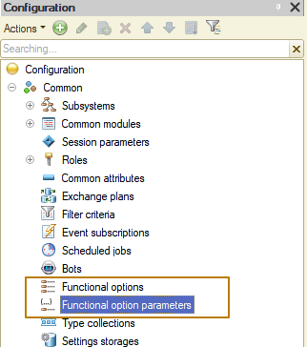
General information
Functional options may have an impact:
- on the user interface - when you disable any functional options, the system hides all elements related to it in the user interface. The following interface elements are affected:
  - global command interface;
  - form details (including columns of form details of the Value Table or Value Tree type);
  - form commands;
  - reports implemented using a data composition system.
Note: If the client application works with the file version of the infobase through the web server, then changing the functional option will lead to a change in the user interface only after restarting the web server (restarting the client application will not change the user interface).
● for algorithms written in a built-in language - it is possible to obtain the values of functional options from the built-in language and use them in various conditions, for example, to reduce the amount of calculations.
Note: Functional options and their parameters do not affect the content of the database. All tables and fields are present in the database regardless of the state of the functional options.
Global command interface
The effect of functional options on the global command interface is that the system hides the commands of all objects related to disabled options. For example, if the value of the UseProduction functional option is False, then the commands for opening the Production section, creating a ProductRelease document, opening the ProductRelease list, etc. will be hidden.
It should be noted that the UseProduction functional option can take into account the value of the functional option parameter, for example, Company (i.e., for one company production is enabled, for another it is disabled). By changing the value of this parameter using built-in language methods, you can change the state of the functional option, and, consequently, the visibility of the interface element.
You should also take into account the following features of the command interface formation:
● The command will be excluded from the command interface if the attribute that is a command parameter is disabled by a functional option.
● The parameterizable command will be excluded from the command interface if the command parameter type is disabled by a function option. If the command parameter type is composite (contains several types), then the command becomes unavailable when all parameter types are disabled.
Using a functional option
Let's look at an example of creating and using functional options. Previously, I added the ability to account for characteristics to the configuration. Let's add the ability for the user to independently enable/disable this functionality using a function option.
I am creating a functional option "Use characteristics"
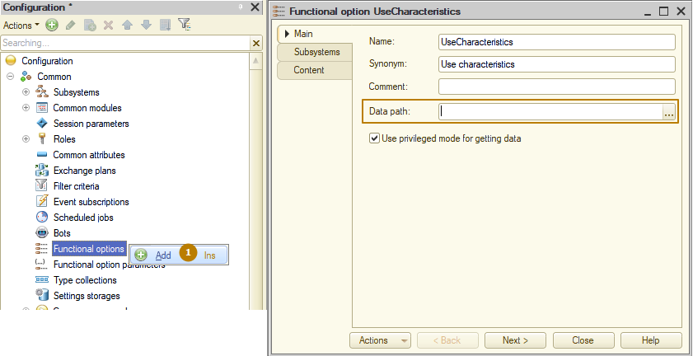
Now I need to indicate where the value of this functional option is stored by filling a value of the Data path property. The list of available objects for this role includes:
● constants,
● catalog attributes,
● resources of information registers.
There is no restriction on the source type of the option value, but only those functional options that store their values ​​in attributes of the Boolean type are suitable for managing the interface. Functional option values ​​with other types are only available for parsing in the built-in language.
I created a constant with the same name as the function option and specified its path as the value that stores the function option:
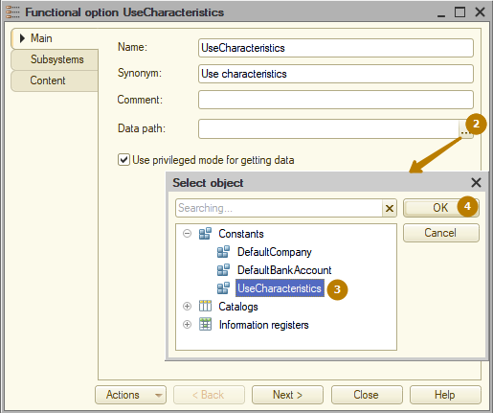
The "Use privileged mode for getting data" property controls how the value of a functional option is retrieved (and cached). If this property is set, the value of the functional option is obtained in privileged mode. The resulting value is cached for all sessions associated with this infobase.
If the "Use privileged mode for getting data" property is turned off, then retrieving the value of the functional option is performed in normal mode. Caching is performed for the current session. Both the value (if it was possible to obtain it) and the sign of the impossibility of obtaining the value (if it was not possible to obtain the value) are cached.
The cache is reset when session parameter values are changed.
Tip: It is recommended to set the "Use privileged mode for getting data" property for all cases where the value of a functional option does not contain sensitive information.
Next, I need to define the objects that should be affected by the created functional option. This can be done from objects on the "Functional options" tab (in the list there will only be functional options whose value is stored in objects of the Boolean type):
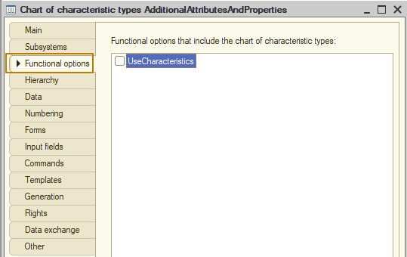
and from the Content tab of the functional option:
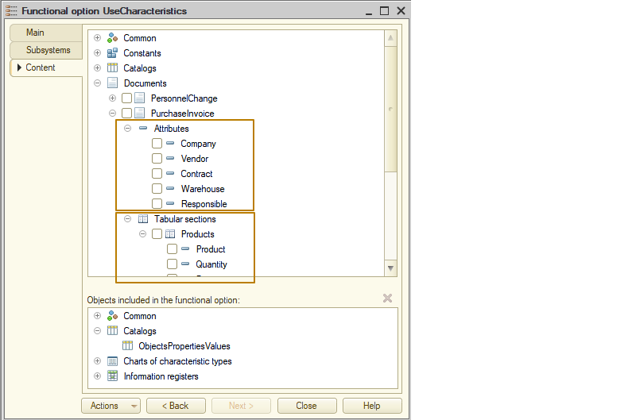
The second method allows you to select objects that are part of a functional option in more detail, since you can select not only catalogs, documents, etc. as objects, but also their attributes, tabular sections, and attributes of tabular sections.
Note: If an object is not assigned any functional options, then it is considered always visible. Otherwise, an object is considered visible if at least one of the functional options assigned to it is enabled (i.e., checking whether functional options for an object are enabled is performed using the "OR" operator).
I include in the functional option the subsystem of characteristics, the ObjectsPropertiesValues catalog, the AdditionalAttributesAndProperties chart of characteristic types and the ObjectsCharacteristicValues information register.
Now I update the database configuration and enter Enterprise mode to check the result.
In the Settings section, a command has appeared for the “Use characteristics” constant, but the “Additional details and properties” subsystem is no longer displayed.
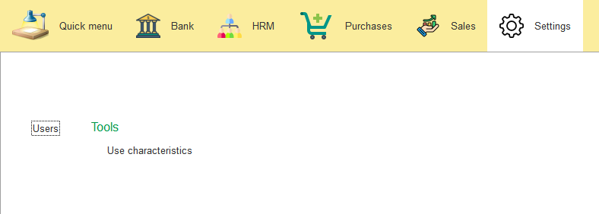 This is because the new constant has default value False, meaning the functional option is disabled.
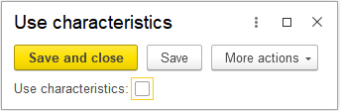
Even in the item form of the Products catalog there is now no transition to characteristics.
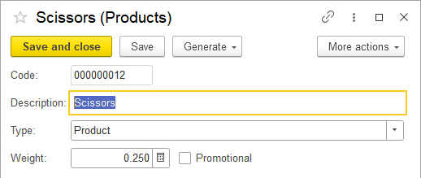

Moreover, if you open one of the objects that are part of a functional option from the functions for a technician (where objects are present regardless of the values of the functional options), …
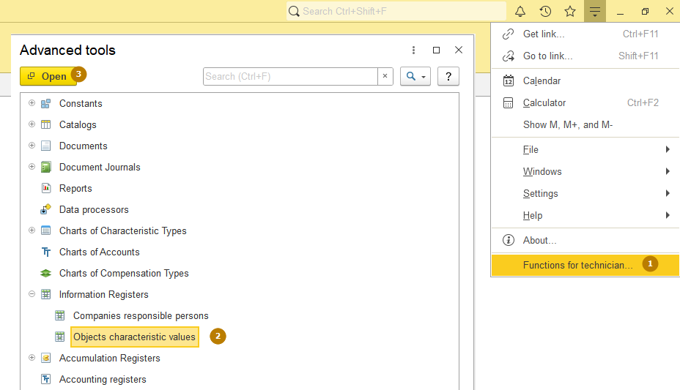...the list form looks like this:
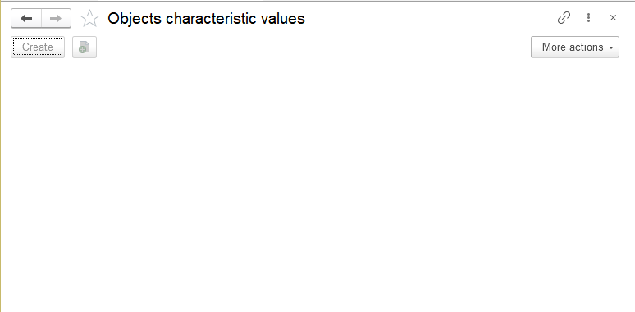
That is, it is clear that the object belongs to disabled functionality and cannot be used. Let's see what happens if I enable the functional option value.

In the item form of the Products catalog, after reopening, a transition to the characteristics appeared:
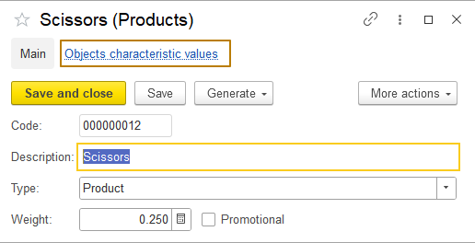
Settings section. The "Additional attributes and properties" subsystem has not appeared, although the functional option is enabled
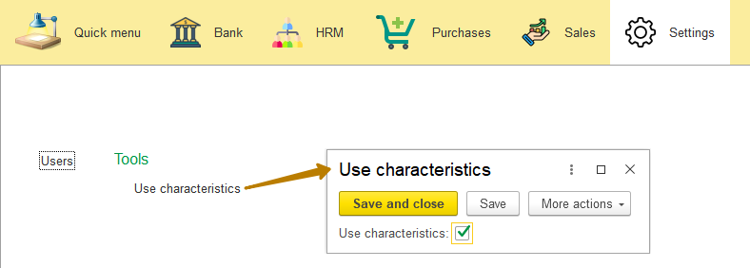
Why does this happen? The fact is that the commands of the global command interface, as well as open forms, are not automatically updated by the system when the value of a functional option changes. If you restart the information base, then the changes will become visible, but this is inconvenient. To apply changes to functional options in the 1C platform there is a global context method RefreshInterface().
However, this method requires a significant amount of resources, so it should be used deliberately, that is, it should not be called every time a functional option changes. Typically, for such purposes, developers of standard solutions create a form with several functional options, grouped into functional blocks (Purchases, Sales, Production, etc.). If a user changes the value of at least one functional option, the developer records in a special variable that after saving the changes, the interface will need to be updated (by calling the RefreshInterface() method).

To demonstrate how this works, I'll change the common form DefaultValues that I changed in one of the previous lessons:
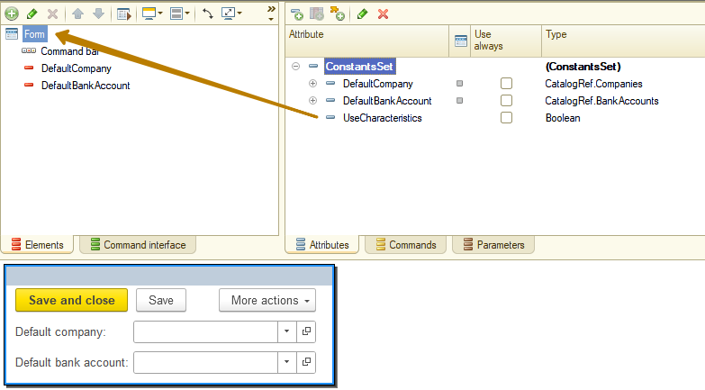
I rename it to ApplicationSettings, and I also add the new function option value to it
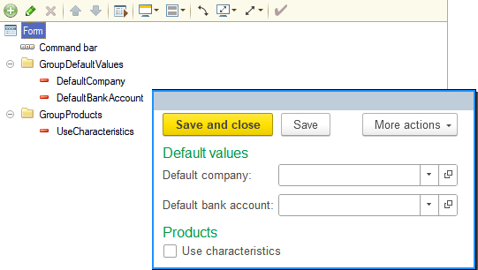
I need a form attribute of the Boolean type, which will store an indication of the need to update the interface. When changing constants that are associated with functional options, I set this attribute to True.
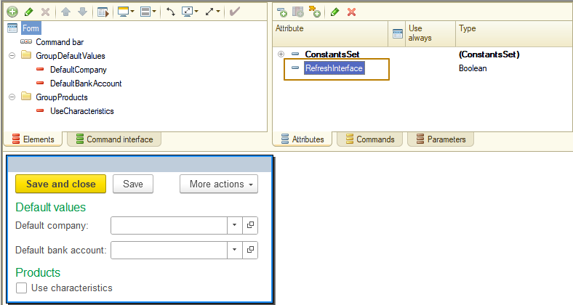
Now I create a handler for the AfterWrite form event, in which I check the value of the attribute and, if necessary, update the interface (note that the interface refresh method is client-side, although it leads to a server call).
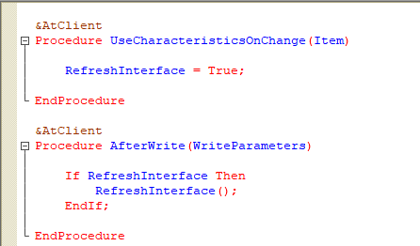
That's it, now changing a functional option updates the global command interface as well as opened forms.
Note: It should be remembered that setting the parameters of functional options (and executing the RefreshInterface() method) leads to the following consequences:
- for each form, the closing of all auxiliary forms is called (with the corresponding handlers being called);
- forms that refuse to be closed are not closed;
- the composition of the elements of the main form is updated;
- if the main form was the active form at the time of updating the interface, the main form is displayed in accordance with the new composition of elements;
- if at the time of updating the interface the active form was an auxiliary form, then:
  - the command to open the auxiliary form will be executed, if it is available after updating the interface;
  - otherwise, the composition of the elements of the main form is updated and it is displayed;
- if at the time of updating the interface the active form was an auxiliary form opened using a command not related to the form navigation panel, then instead of this form the composition of the elements of the main form will be updated and it will be displayed.
Form attributes and commands can also be used in the functional options mechanism. To do this, they have the "Functional options" property, where you can select one or more functional options. The visibility condition here is the same as for configuration objects: if one or more functional options are assigned to a form attribute/command, such an attribute/command is considered visible if at least one of the functional options assigned to it is enabled. If functional options are not assigned, then the form attribute/command is considered always visible.
Form attribute:
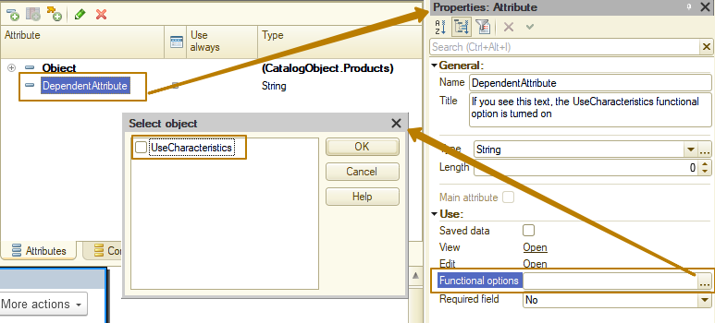

Form command:
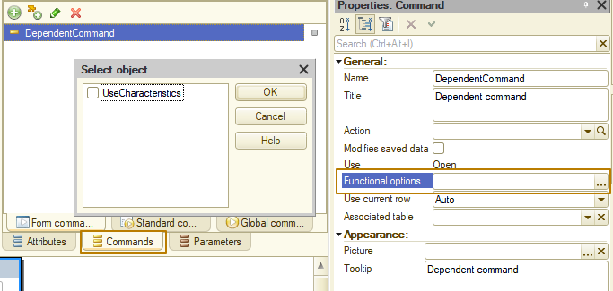
The functional option is turned off:
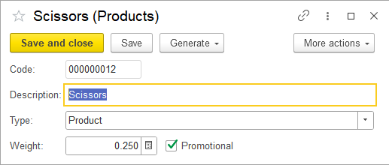
Turning on the functional option leads to refreshing the form:
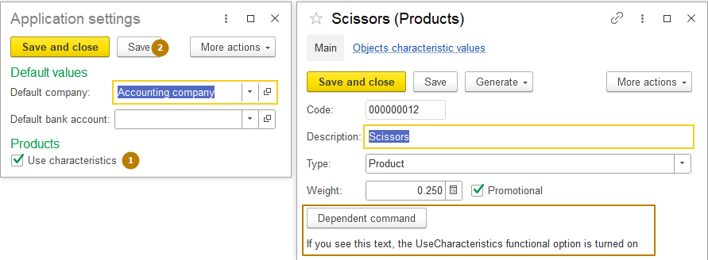
I also note that functional options are not always used to change the command interface. Sometimes this is just a convenient tool for retrieving some value without having to take into account user rights, as well as caching the value to optimize frequent retrieval of values from code.
Functional option parameters
As we learned earlier, the functional option parameters are needed in the case when the value of the functional option should be obtained with some clarification, for example, whether accounting is carried out in terms of contracts for company 1. In this case, you need to create the functional option UseContracts (or AccountingByContracts), as well as the Company functional option parameter. If a functional option stores a value in a catalog attribute, then the value type of the Use property of the Functional option parameter must be CatalogRef.Companies. If a functional option stores a value in an information register resource, then the value type of the Use property of the Functional option parameter must be a dimension of the same information register with the CatalogRef.Company type.
In this case, one functional option parameter can be used for any number of functional options. The list of available objects in the Use property includes catalog references and information register dimensions. For each functional options parameter in this list, you can select one catalog (from the entire list of catalogs) and one dimension of each information register.
Note: You cannot use the same metadata object in multiple function option parameters.
Let's look at both examples (storing a functional option in a catalog attribute and in an information register resource) for a better understanding.
I create 2 functional options:
- CompanyPrefix that will be stored in the details of the Companies catalog (this attribute is not in the catalog, I will create it). The company prefix is usually used to separate the numbers of documents of the same type in the program. So, instead of documents receiving a general numbering (for example, document 0001 belongs to company 1, document 0002 belongs to company 4, etc.), they are numbered separately by company, for example, document AB0001 belongs to company 1, document CH0001 belongs to company 4, etc.
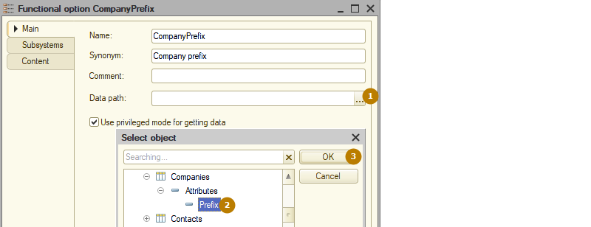
I do not include objects in this functional option because it is not a separator and is intended to simply obtain the organization prefix.
- UseContracts, which will be stored in the CompanyAccountingSettings information register resource (which I will need to create). In the same register, I can create other resources regarding separate settings of companies, for example, whether to use tax accounting, etc.
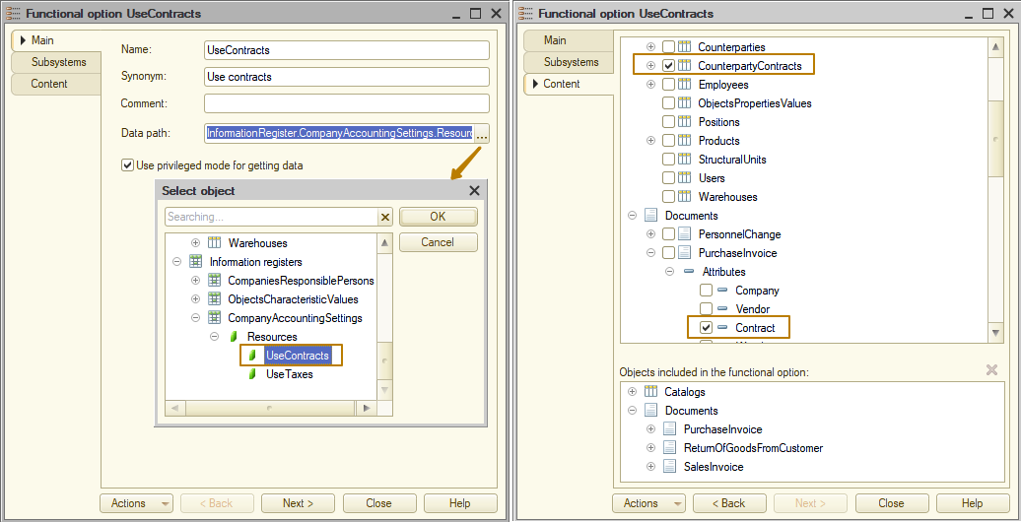
I include the CounterpartyContracts catalog itself and the Contract attribute of documents in which this attribute should be hidden from the forms when the functional option is disabled in a content of this functional option.
Next I create the Company functional option parameter, in which I must select a reference to the Companies catalog for the CompanyPrefix functional option and the CompanyAccountingSettings register dimension with the type CatalogRef.Companies.
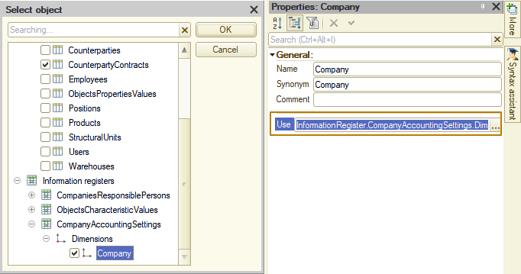
Do you remember that to update the global command interface and open forms, you need to call the RefreshInterface() method after changing the value of a functional option? So now the value of the UseContracts functional option is stored in the information register, which means you I need to repeat the same operation that I did for the general form of constants, for the register record form:
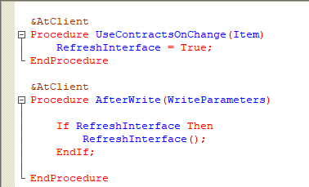
Now I update the database configuration and run the program as the user. I added 2 records to the new CompaniesAccountingSettings information register, but did not turn on the UseContracts and UseTaxes flags
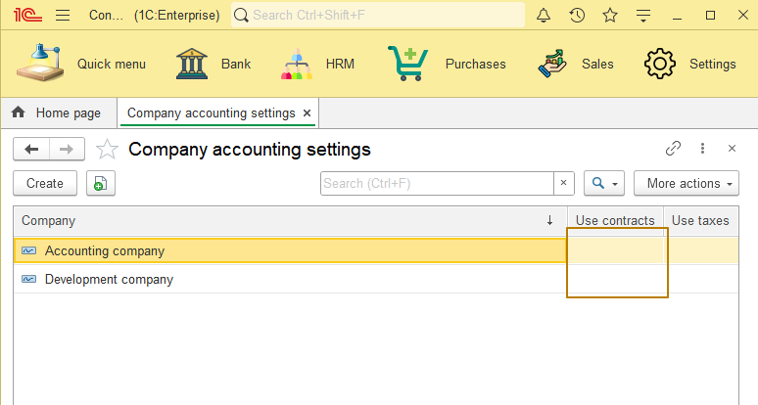

First, I check the visibility of the CounterpartyContracts catalog in the Sales section. It's not there. So far so good.
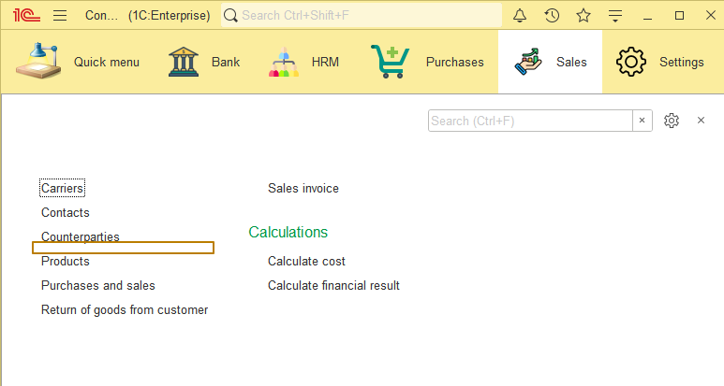
Now I turn on the UseContracts flag for one of the companies
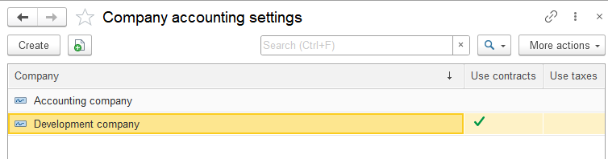and check again
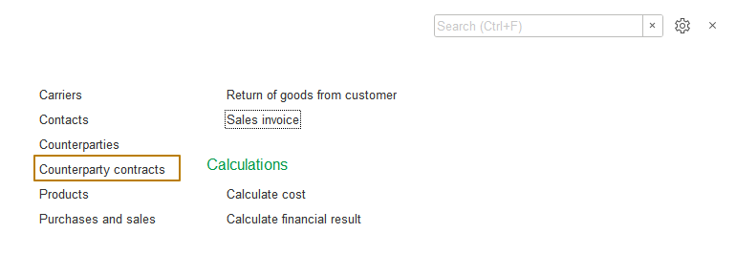
Now the command to open the catalog list form has appeared. This is correct behavior, because if UseContracts flag is enabled for at least one company, then this catalog need to be displayed in the global interface so that the user can work with this object.
Next I check the visibility of the Contract field in documents for various companies. Please note that for the "Accounting company" I have contract accounting turned off, and for the "Development company" it is turned on.
I open a SalesInvoice document with the "Accounting company" company and see that the Contract field is present on the form. But why? The UseContracts flag is disabled for this company and one of the document attributes is a part of the functional option. The fact is that the platform cannot automatically determine with which parameter the value of a functional option that includes the Contract attribute should be obtained. As a result, it calculates the value of the functional option in the same way as for the global interface - that is, if the value is True in at least one register record, then the value of the functional option is also True, if there is no specification among which register records to check the value of the resource. There are global methods for this purpose, intended for use in forms.
In our case, I must use the SetParametersFormFunctionalOptions(<ParametersStructure>) method. The parameters structure must contain parameter names and their values. I have one such parameter - Company; I must pass the value of the document Company as a value. I create this procedure:
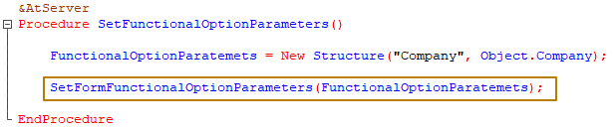
...and now must call it from events that occur when the form is opened, as well as when the company changes, since for another company the value of the functional option may be different. Therefore, I create an event handler for the OnChange event of the Company form field. And for events that occur when a form is opened, the form's OnCreateAtServer event is suitable.
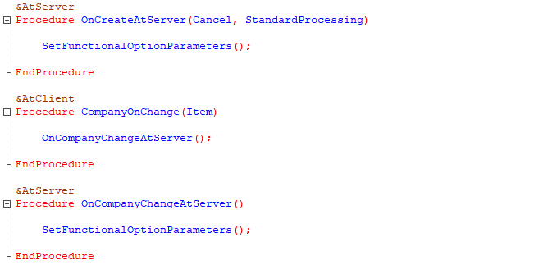
I save the configuration and check. When opened, the Contract field is displayed on the form
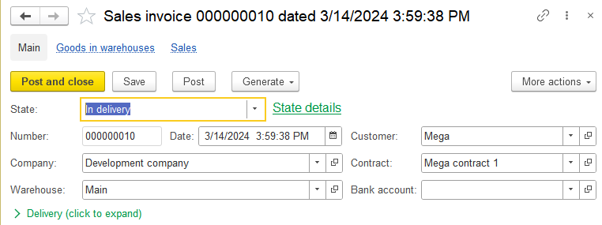
When the company changes or functional option for this company turns off, it is hidden
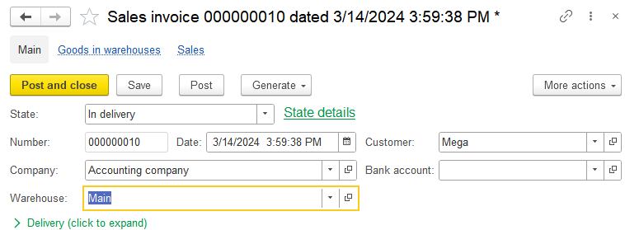
Please note that if the property of the "Required field" attribute takes the value "Display error", then if such a property is disabled by a usual functional option, the check will not be performed. But if it is disabled by a parameterizable functional option, the check will be performed even though the field itself is hidden from the form. In this case, it is necessary to implement the exclusion of the attribute from the list of checked attributes in the event handlers of an object (or form).
Let's return to our second parameterizable functional option, CompanyPrefix. It is much easier to work with it, because it does not affect the interface and is only needed to more easily obtain company’s data. In order to receive a functional option, there is the GetFunctionalOption function, which has an optional parameter Parameters of the Structure type, to which parameters should be passed in order to obtain the value of the functional option with clarification based on some data (in our case, by Company).
As a result, in order to get the value of the company prefix, it is enough to call the GetFunctionalOption function, passing into it a structure, where the key is the name of the functional option parameter (Company), and the value is the reference to the company whose prefix we need to get:
FunctionalOptionParameters = New Structure("Company", CompanyValue);

Prefix = GetFunctionalOption("CompanyPrefix", FunctionalOptionParameters);

Object and non-object entities
So, it’s time to learn more about the differences between object and non-object entities, as well as in what cases to choose one or another type of entity to implement a task.
Object entities in 1C Enterprise include any objects that can have references: catalogs, documents, charts of characteristic types, charts of accounts, charts of calculation types, exchange plans, business processes, tasks. What is their feature? Object entities are those entities in which each object is unique, even if there is an object in the database that is filled in exactly the same way. This is achieved due to the object having a unique identifier, which remains unchanged throughout the entire life of the object, even if all its other details and tabular sections change their values.
For example, if you create 2 objects in the Products catalog and fill them out absolutely identically, then each of them will have its own reference and accounting for such objects will be kept separately.
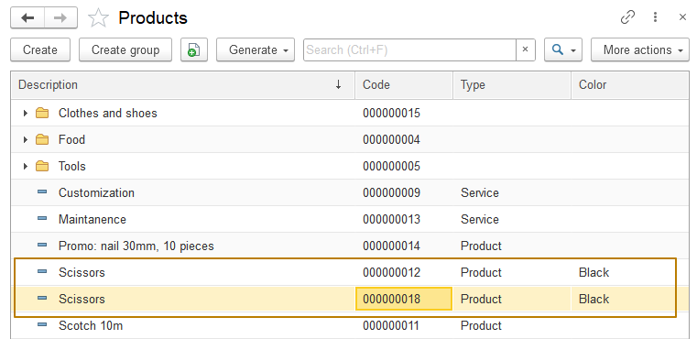
Note: if uniqueness control is enabled for an object, then the attribute(s) that determine uniqueness cannot be filled with the same values. For example, for Products catalog with "Check uniqueness" property enabled, you cannot have 2 objects with the same code.
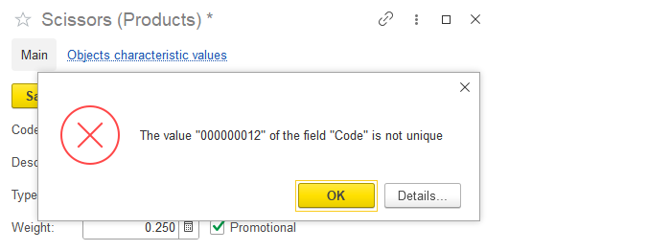
I am creating a document Purchase invoice, in which I include both products “Scissors” with the same details filled in, but different links. Let's say we bought 50 pieces of each of these goods.
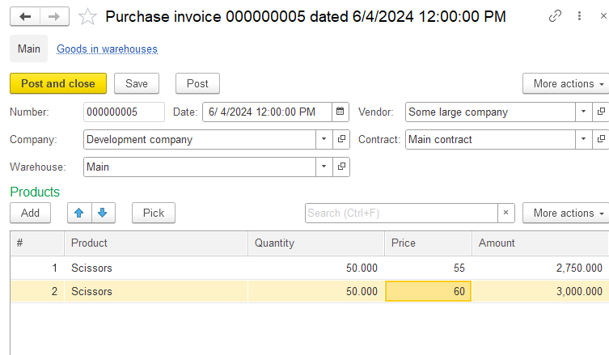
Now I create a document Sales invoice and try to sell 65 units of the first scissors and 55 units of the second
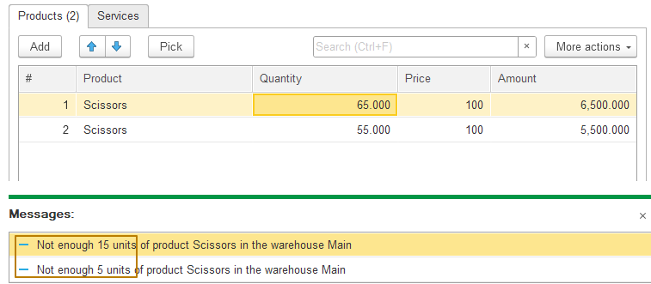
As a user of the system, I noticed that working with such products in the program is inconvenient, since visually they are no different, although since 2 items were created in the program, they are either different in reality, or this is an error and I need to leave only one item of the products out of two. In my case, I found out that some of these scissors are small and others are large, so I decided to adjust the description of each of them in the system. Now I will rename some scissors to Small Scissors, and others to Large Scissors.
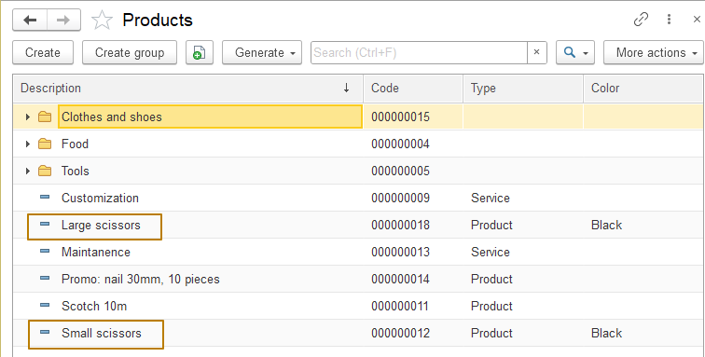
Thanks to referential integrity, the presentation of references has changed and looks new in all places of the program where those object are used
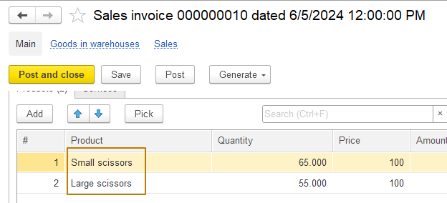
Perhaps the example with scissors is not the best, because one element of the Products catalog characterizes not just one specific scissors, but any quantity of goods with certain characteristics (you can buy a batch of such scissors, just like in my purchase and sale documents).
Let's consider a more precise example of the uniqueness of object entities - this is the Individuals catalog, in which data is maintained to record information about real people. Each person is unique despite the possible changes that occur to him. For example, a person can change their position, marital status, last name, and even gender, but this is still the same person for whom the element in the catalog was once created. Therefore, the object for accounting for individuals must be an object entity.
Now let's move on to non-object entities using the example of individuals. Suppose we have a need to store the history of positions held by a person in a company. For example, John held the position of developer from 01.01.2022, moved to the position of senior developer on 13.03.2023, and took the position of head of the development department on 01.05.2024.
What will such records look like in the system?
Period | Individual | Position
01/01/2022 | John | Developer
03/10/2023 | John | Senior Developer
05/01/2024 | John | Head of Development

What happens if I change the value John in any of these records to any other value, for example, Michael? Will this record mean the same as before the change? No, this will be a completely different data, not related to John in any way. This means that in this case we are talking about storing data for which uniqueness, which allows us to uniquely identify an object at any stage, is not required.
All registers are non-objective entities and the records in them are a reflection of some information (what is the car’s mileage odometer on the date of service maintenance, how many goods we sold and for what amount, etc.). Changing the key fields in the registers automatically changes the meaning of such records.
From the information above it follows that the choice of an object for storing any information should be determined, among other things, by what entity the information base object will reflect. In this case, special attention should be paid to object names. In the examples above, the catalog is named Individuals, and the information register is named Employee Positions.
Referential integrity
In the section about object and non-object entities, as well as in one of the previous lessons, we have already encountered the concept of referential integrity using the example that when the representation of an object changes, all references to it also change their representation in all places of use. In addition, in the lesson on information registers, we learned that when you enable the Master flag for a dimension, the register records are subordinate to the object they refer to in the value of that dimension. When an object is deleted from the database, such records will be deleted automatically.
Let's look at the other features of referential integrity and find out what ways there are to remove objects from the information base.

There are 2 ways to delete object entities from the infobase:
- direct deletion
- marking for deletion and subsequent deletion with referential integrity control
The first method is unsafe when it comes to deleting object entities. Such references remain in the database, but they lead to non-existent objects, which can lead to errors built into the algorithms, and also looks unfriendly to the user, because such links do not have a normal representation and simply look like identifiers.
By default, direct deletion of an object is not available from the context menu and is only available in the “More actions” submenu in the form of an element/object or list form:
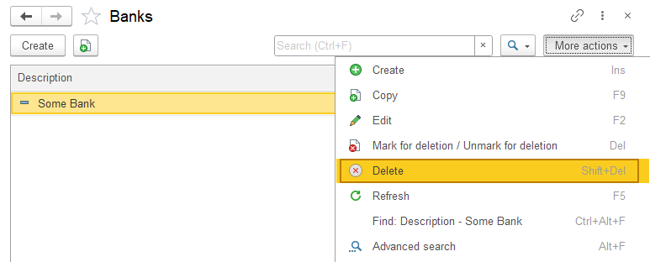
Deleting using a deletion mark command is the preferred method for deleting object entities because in this case, the user has the opportunity to change his mind about deleting the object (in this case, he can remove the deletion mark from the object); if the object is nevertheless deleted through the "Delete marked objects" service processing, the system analyzes the presence of references to the deleted object that will remain after its deletion and, if it finds such references, prohibits the deletion of an object before these references are also deleted (for example, the values of attributes containing references are replaced with others or cleared), or objects containing such references are deleted.
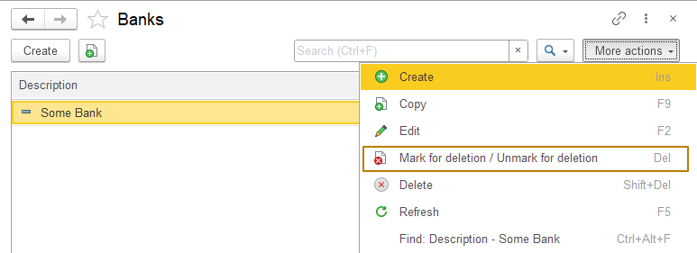
Service tool for deleting marked objects is located in the "Standard" section of the "functions for technician" menu:
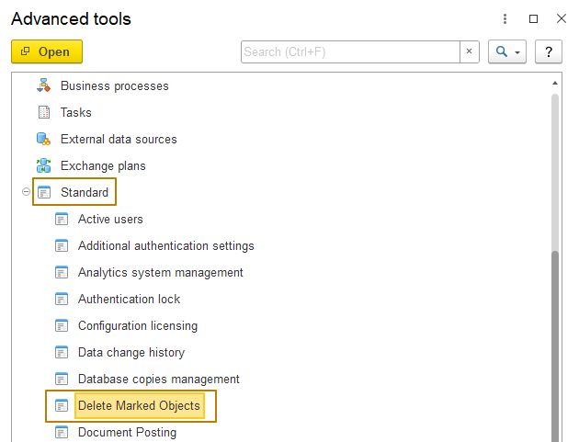
When opened, it displays a switch with two options:
- "Full deletion" to delete all marked objects
- "Selective deletion" to delete only user-selected objects.
I recommend using selective deletion, since this eliminates the possibility of wrong deleting objects that should not have been deleted (for example, the user wanted to unmark an object for deletion, but has not yet done so):
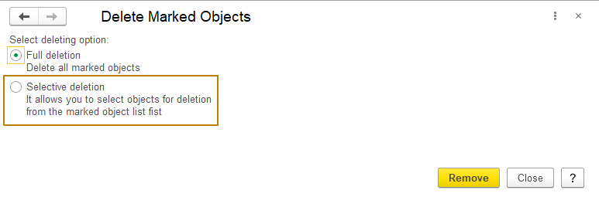
In the next step, the user can view the list of objects marked for deletion and leave enabled only those that he wants to try to delete. If there are a lot of objects marked for deletion, the user can use the “set all” and “clear all” commands, or set/clear flags on metadata objects in the tree, for example, unmark the Products catalog, then the flag will be unchecked from all objects of such type.
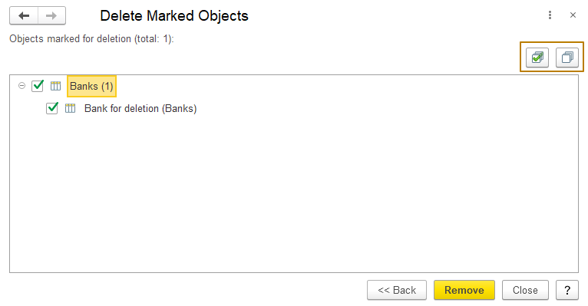
When attempting to delete objects that have references, the user receives a corresponding message and can view the objects that reference the object being deleted
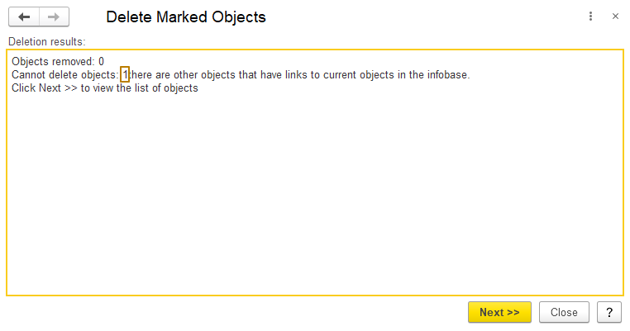
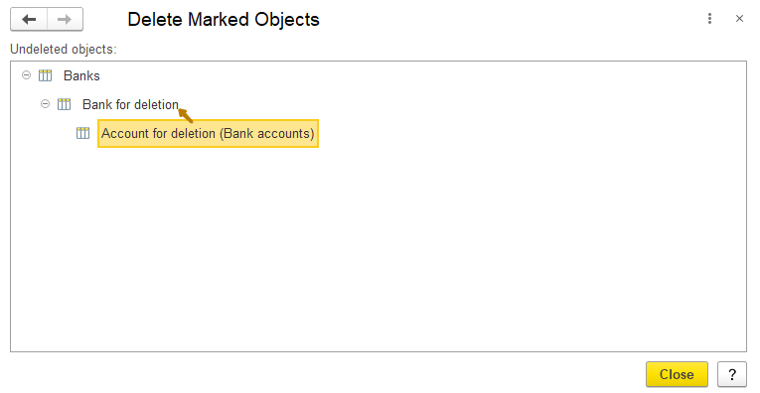
This is the control of referential integrity on the part of the platform. In this case, for the bank marked for deletion (Bank for deletion), there is a bank account (Account for deletion) for which the owner is the bank being deleted. In order to successfully delete this bank, I need to either remove the reference to it in the bank account, or also mark it for deletion and delete this bank account.
We have not yet studied roles and access rights, so now I will just briefly say that for deleting and marking for deletion, there are separate access rights issued to objects in objects of the Role type. Direct deletion is granted by the Delete right, and the ability to set a mark for deletion in interactive mode (from the form) is granted by the “Interactive mark for deletion” access right. We will talk more about this in the corresponding lesson.

